
Formally adopted by the Governing Board of:-
Drake Primary School
Chair of Governors:-
Holden Cook
Brought to Governors & adopted on:-
20.1.26
Special Educational
Needs and Disabilities
SEND) Policy and
(
Information Report
J
a
n
u
a
r
y

2
0
2
6
H
A
L
C
Y
O
N

F
E
D
E
R
A
T
I
O
N
S
E
N
C
O
@
D
R
A
K
E
.
N
O
R
F
O
L
K
.
S
C
H
.
U
K
2 Contents
2
Statement of Intent
Contact Details 3
Legal Framework
Roles and Responsibilities 4
Identifying and Assessing 5-6
Pupils with SEN
SEN Provision at Halcyon 7-13
Autism Specialist Resource Base 14-15
SEND Profile at Drake 16 - 17
Pupil and Family Voice 18
Expertise and Professional 19 - 20 Development
Norfolk’s Local Offer 21
SEN Funding 22
Transitions for Pupils with SEND 23
Facilities 24
Signposting and Complaints 25
Halcyon SEND Toolkit 26-30

Statement of Intent
At Drake primary school, we are proud to provide learning for all children who attend our setting, including children with Special Educational Needs and Disabilities (SEND).
We want all children to meet their full potential by receiving high quality, adaptive teaching and individualised provision.

Legal Framework
This report has due regard to legislation including, but not limited to, the following:
The Children and Families Act 2014
The Equality Act 2010
The Special Educational Needs and Disability Regulations 2014
This report has due regard to the following guidance:
DfE (2015) ‘Special educational needs and disability code of practice: 0-25 years’
This report has due regard to the following school policies:
Supporting Pupils with Medical Conditions
Administering Medicine Policy
Intimate Care Policy
Safeguarding Policy
Equality and Diversity Policy
Disability Arrangements
Accessibility plan
Relationships Policy Anti-bullying Policy
Complaints Policy
This SEND policy is reviewed annually in line with statutory requirements.

33
Roles and 44
Responsibilities

The Governing Body
Our named Governor for SEND is Tamsin Robertson.
The Governing body will determine the setting’s policy and general approach to the provision for children with special educational needs, maintaining a general oversight of the setting’s work.

Head Teacher
Our Executive Head Teacher is Louise Clements McLeod.
The Head of School for Drake Primary School is Victoria Langley.

The Head of School has the responsibility for the day to day management of all
aspects of the setting, including the provision for children with special educational needs and disability. The Head of School, with support from the SENDCo, will keep the governing body fully informed. The Head Teacher will work with the SENDCo and staff to ensure that the policy is put into practice.

SENDCo
Our SENDCo for Drake Primary School is Hannah Bridge.
The Assistant SENDCo at Drake Primary School is Marianne Starling
They have responsibility for all pupils with Special Education Needs. They provide professional guidance to colleagues and work closely with staff, parents and other relevant professionals.

Class Teacher
Teachers are responsible and accountable for the progress and development of all pupils in their class, including those with Special Educational Needs. Teachers are responsible for delivering high quality, adaptive teaching and, with the support of the SENDCO, ensuring that the provision and outcomes identified for pupils are fulfilled. For more information, please see SEN Provision at Halcyon.
Identifying and Assessing Pupils with 55
SEN
According to the SEND Code of Practice, a child or young person is classified as having SEN if they have:
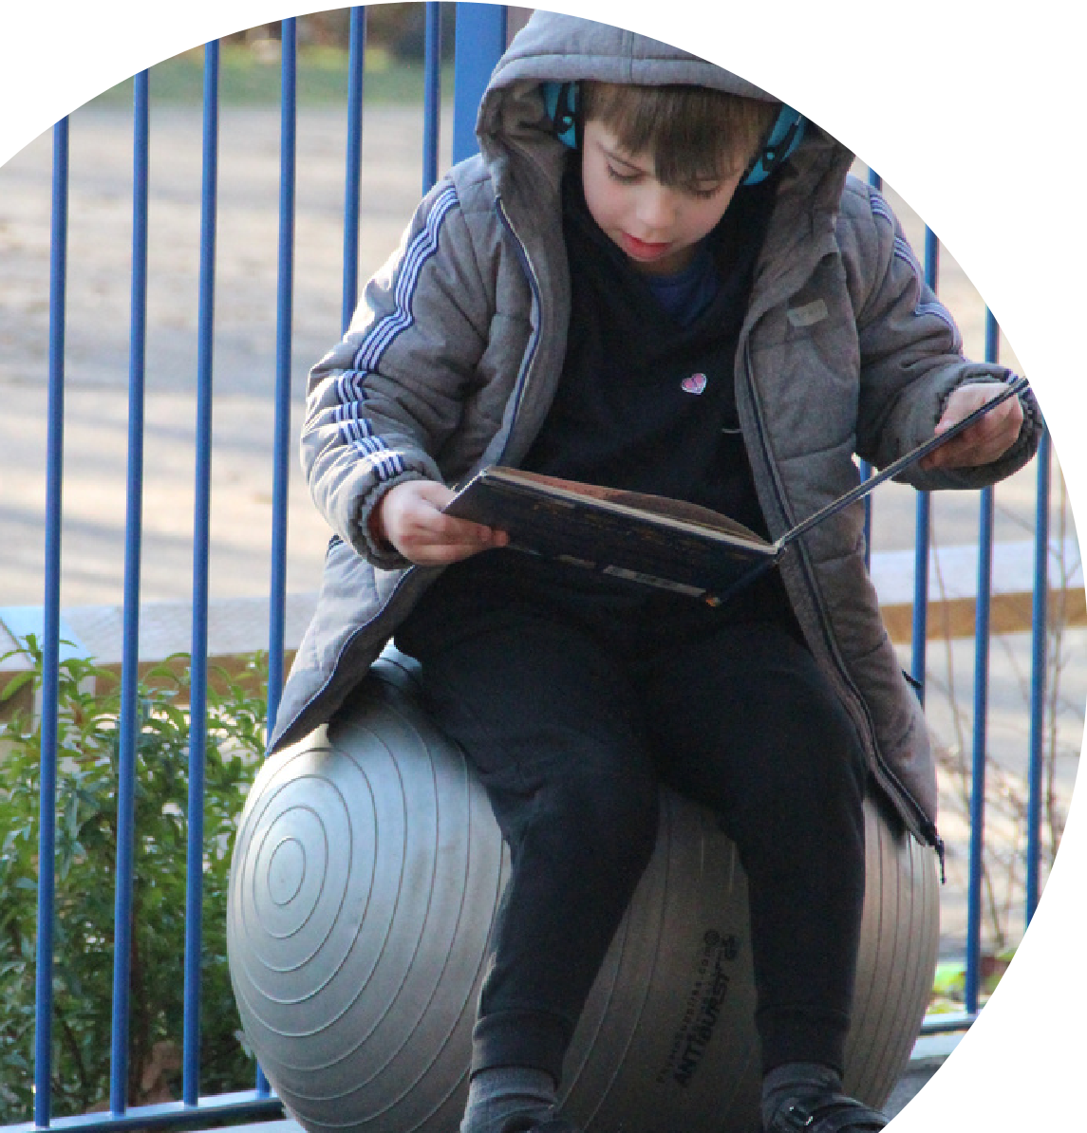
“A significantly greater difficulty in learning than the majority of others of the same age”.

Assess
P
l
a
n
D
o
R
e
v
i
e
w
Pupils who are having difficulty in learning are identified primarily through observations from their class teacher and wider professionals working within the school. They may also be identified through attainment and progress tracking, attendance data and additional monitoring by the Pastoral Team.
Once difficulties have been identified and shared with the child’s class teacher, a process called The Graduated Approach begins which can be explained as the ‘Assess, Plan, Do, Review’ cycle.
Identification of SEN Flowchart 66
This flowchart demonstrates the process for initial identification of SEN at Drake.
Once a SEN need has been identified, the pupil will be added to our SEN/D register. The pupil and their parents are informed, and co-create a One Page Profile and Individual Support Plan to share their thoughts, experiences, wishes and provision.
Identify Concerns:
Attainment and Progress assessment
Observations
Pupil and Parent Voice
Initial Information Gathering: Pastoral Referral Form
Identification of Need Descriptors
Pastoral Team Next Steps:
These could include:
SEND team to complete an observation
Initial discussion meeting between the class teacher, SENDCo and Parents to identify barriers to learning.
Use of specific toolkits to assess need
If SEN
Need is
Identified
SEN Support
Pupil and Parents informed
Pupil added to SEN register
One Page Profile
Individual Support Plan
SEN Provision at Halcyon 77

Areas of Need
The support offered to children will depend on their area(s) of need and individual learning styles. The SEND Code of Practice categorises need into four broad areas as shown below. Within Norfolk, schools use a framework called ‘Identification of Needs Descriptors in Educational Settings (INDES)’ to break down the broad areas of SEND into seven specific sections. The INDES framework generates precise statements to describe need and generates a score for each specific area of SEND to create an “at-a-glance” profile.
Code of Practice Norfolk County
Broad Area of Council Definition Need INDEs
Support may be required when children learn at a
Learning and varied pace than their peers, even with appropriate
Cognition and ^{Cognition} differentiation. Learning difficulties cover a wide range
Learning (behaviour forincluding of needs including specific difficulties with one area of learning) learning as well as moderate to severe difficulties,
where children are likely to need support in all areas.
Social Children with Speech, Language and Communication
Communication communication Needs have difficulty communicating with others. This and Interaction and interaction_{Speech and} themselves, understanding what is being said to themmay be because they have challenges expressing
Language or they have differences in their social interactions.
Children may experience a wide range of social and emotional difficulties which present in different ways.
Social, Emotional These include becoming withdrawn, isolated and and Mental Social, emotionaland mental health displaying dysregulated or distressed behaviour.
Health Behaviours could reflect an underlying metal health
difficulties such as anxiety or depression, self-harming,
or physical symptoms that are medically unexplained.
Physical disability (including physical
and neurological Some children require special educational support
Sensory and/or ^{impairment,} because they have a disability which prevents them or
Physical medical,independence and generally provided. These can be age related andhinders them from making use of the facilities
sensory) fluctuate over time.
Deafness
Visual Impairment

SEN Provision at Halcyon 88

Layers of provision
After we have identified a child’s individual profile of need, we determine the provision needed for them to thrive. Provisions can be grouped into universal, targeted and specialist, as shown in the diagram below.
Specialist
highly personalised
Targeted
small group / key adult targetted support

Universal
Reasonable adjustments
High quality, adaptive teaching
As a result of our Universal offer, some children with specific special educational needs, such as dyslexia or autism, may not need targeted or specialist provision.
Only children receiving provision additional to or different from universal provision will be named on our SEND register and receive an Individual Support Plan.
Reasonable Aadjustments- Pupils with Special Educational Needs and Disabilities (SEND) may require reasonable adjustments to ensure equitable access to learning and school life. At Drake Primary School, some children will benefit from adaptations
made within our universal provision, including the use of supportive equipment such as ear defenders, sensory resources, fidget tools, and flexible seating or sitting arrangements. Staff follow the school’s individual guidance document on the
identification and implementation of reasonable adjustments to ensure these adaptations are appropriate, consistent, and responsive to each child’s needs.

Identifying Pupils with Medical Need
Medical or physical impairments and disabilities are identified when a child enters our school roll or through notification by their parents and healthcare professionals. They are invited to attend a meeting to create an Individual Healthcare Plan (IHCP). Medical professionals are invited if necessary and IHCPs are updated annually.
For further information, please see our Administering Medicine Policy.

Education Health and Care Plan (EHCP)
What is an EHCP?
An Education Health and Care Plan (EHCP) is a legal document written by the local authority. It is aimed at children and young people with high support needs in Education, Health and / or Social Care that cannot be solely met through SEN support in school.
Does my child need an EHCP?
If a pupil is receiving specialist support in school, they may require an EHCP. Parents and pupils will meet with the SENDCo to discuss next steps including an application of an EHCP needs assessment.
We strive to communicate with pupils and parents at all stages of a pupils’ SEN journey in school and so an EHCP application should not be sudden or surprise decision.
When completing an application, the school need to evidence that we are unable to meet your child’s needs and have sought specialist advice from outside agencies.
How to complete an EHCP application
The first step is to contact the SENDCo directly to discuss the support in place, your child’s progress and our schools planned next steps. In most cases, an EHCP application will be made through the school.
In the unusual circumstance where the school does not apply, parents can make a request for an EHCP assessment directly to the authority. Please let our school know if you decide to make a parental request as we will be contacted by the local authority to provide information.
More information on this by Norfolk County Council can be found here.
Provision Expected at SEN Support (PEaSS)
Drake Primary School follows Norfolk County Council’s Provision Expected at SEN
Support (PEaSS) guidance. This framework outlines the core provision that all mainstream schools in Norfolk are expected to offer for pupils with SEND as part of high‑quality, adaptive teaching. Our universal, targeted and specialist provision is
aligned with PEaSS to ensure that pupils receive appropriate support at SEN Support before any consideration of an Education, Health and Care Plan (EHCP). PEaSS also guides our use of the graduated approach and helps us ensure that provision is99 consistent, evidence‑based and responsive to individual needs.

Provision Map
Provision of specialist Individual support forIndividual Individuallearning specific accessHigher level technological support in target progress environment arrangements equipment teaching
Homunculi 1:1/Small Handwriting OccupationalExternal Approach ^{Pre-} group work intervention or
teaching
Physiotherapy Precision
Zones Profile ^{Specialised} Teaching Fast trackphonics ^{Use of} Virtual school
(IRMP) Screeningtools readingbooks Chunking curriculum,Adapted technologye.g. Clicker or sensoryexternalsupport
therapyPlay and talkingDrawing Writing framesinformation outcome andresourcesdelivery, Displays and for assessmentarrangementsAccess
working walls
ELSA Visual rules Vocabularyboards Seating SensoryCircuits
Regulationindividual^{Zones of} The PACE Attention andlisteningsupport and learningCognition arrangementsBrainMultisensoryLearning co-ordinationSpecific
support Approach breaks support Forest Social, The daily
Forest SchoolNurture RelationshipsSchool EmotionalMentaland ChildThe Physicaland Physical mile care planIntimate
PolicyMindfulness Health Sensory CurriculumEducation Health CareIndividual
Pastoral Communication Fine and Plan
Support Plan ^{Trauma-informed} and interaction gross Motor activities Small group
PSHE Visuals motor
Boxall small Step OnNorfolk Boxall Circletime Social WellComm Support forinterventions group
The Zones of Visual Stories rich environmentsCommunication transitions
Step UpNorfolk Art therapy Regulation timetable environmentsbetween
Playgroundmonitoring Check-in’s Read, Write Inc Routines Regulationspace equipment e.g.Specialistbraille-
Mental health
trained LSA Speech and translation language Increased
intervention (LSA) Social skills Personalised use of software
External group social stories specialist IT
agency Lego Individualised mental healthsupport Colourful Therapy Blank level Pre-teachingvocabulary Speech andLanguage physical orsensory
Semantics questioning therapy (SaLT) support
Friendship Individual Attention equipment e.g.Specialist Communicationboards
Terrace timetable Autism high tech AAC
Areas of SEND Universal Targeted Specialist
Universal
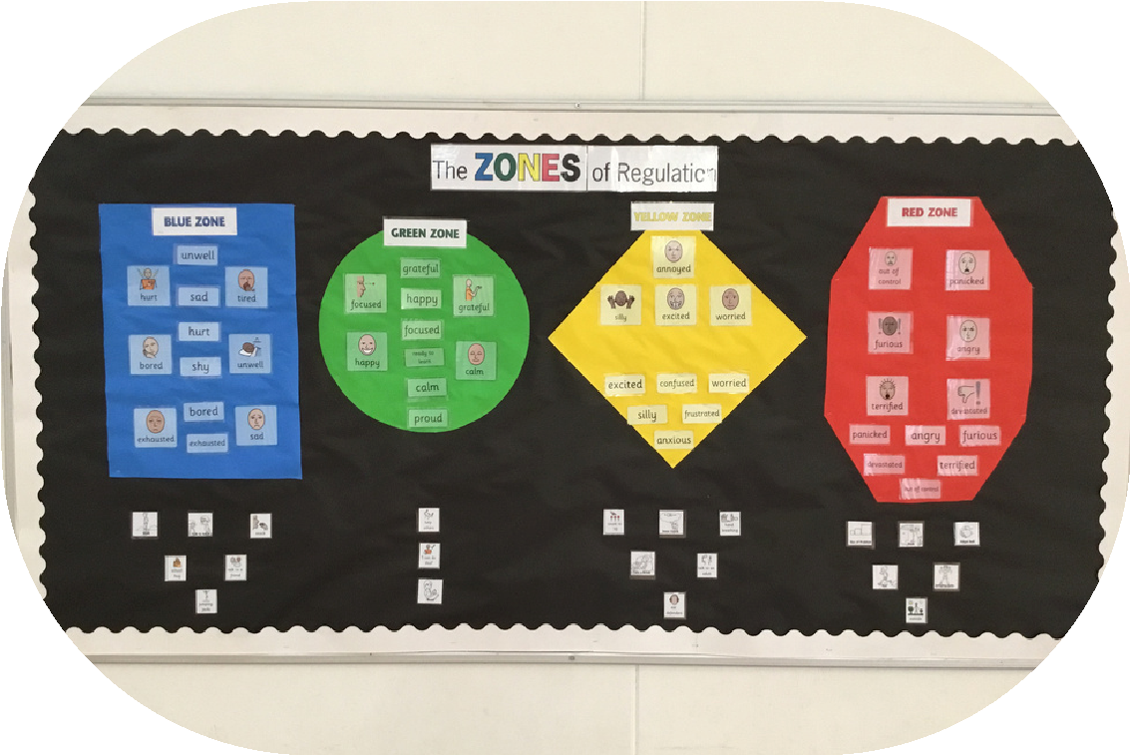
Adapted curriculum, delivery, outcome and resources
Writing frames
Vocabulary boards
Chunking information
Interactive displays and working walls
Seating arrangements
Multisensory learning
Attention and listening support
Brain breaks
The daily mile
Relationships Policy
Visual rules on display
Embedded routines and high expectations for all
The PACE Approach
Forest School
Mindfulness
PSHE curriculum
Norfolk Step On
Boxall Profile
The Zones of Regulation
Regulation spaces
Circle time
Trauma-informed approaches
Whole class visual timetable
Emotional wellbeing check-in’s
Social stories for events and outings
Read, Write Inc
Communication rich environments
WellComm assessments
Use of a range of visual supports
Fine and gross motor activities
Physical Education curriculum
The daily mile
Brain breaks

Targeted

Lego Therapy
Precision Teaching
Key adult support
Small group work
Sensory Circuits
ELSA
Drawing and talking
Pre-teaching
Handwriting intervention
Fast track phonics
Use of technology e.g. Clicker
Specialised reading books
Screening tools
Access arrangements for assessment
Blank level questioning
Colour semantics
Social skills group
Personalised social stories
Playground monitoring
Zones of Regulation individual support
Increased use of specialist IT/ Access to technology
Speech and language intervention (LSA)
Pre-teaching vocabulary
Nurture Forest School
Pastoral Support Plan
Boxall small group
Art therapy
Small group motor interventions
Individual Health Care Plan
Intimate care plan
Specific co-ordination support
Support for transitions between environments

Specialist
Attention Autism
Friendship Terrace
Individual support in teaching
Specialist equipment e.g. high tech AAC
Play therapy
Individual support for target progress
Provision of specialist technological equipment
Individualised/ bespoke timetable
Individualised learning environment
Speech and Language therapy (SaLT)
Communication boards
Mental health trained LSA
External agency mental health support
Zones Profile (IRMP)
Norfolk Step Up
Homunculi Approach
Individualised physical or sensory support
Specialist equipment e.g. braille-translation software
External Occupational or Physiotherapy
Virtual school or sensory external support
Higher level specific access arrangements


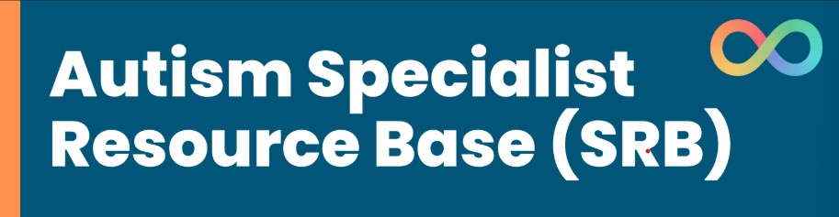
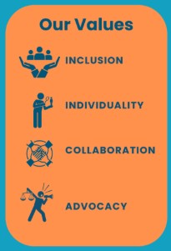

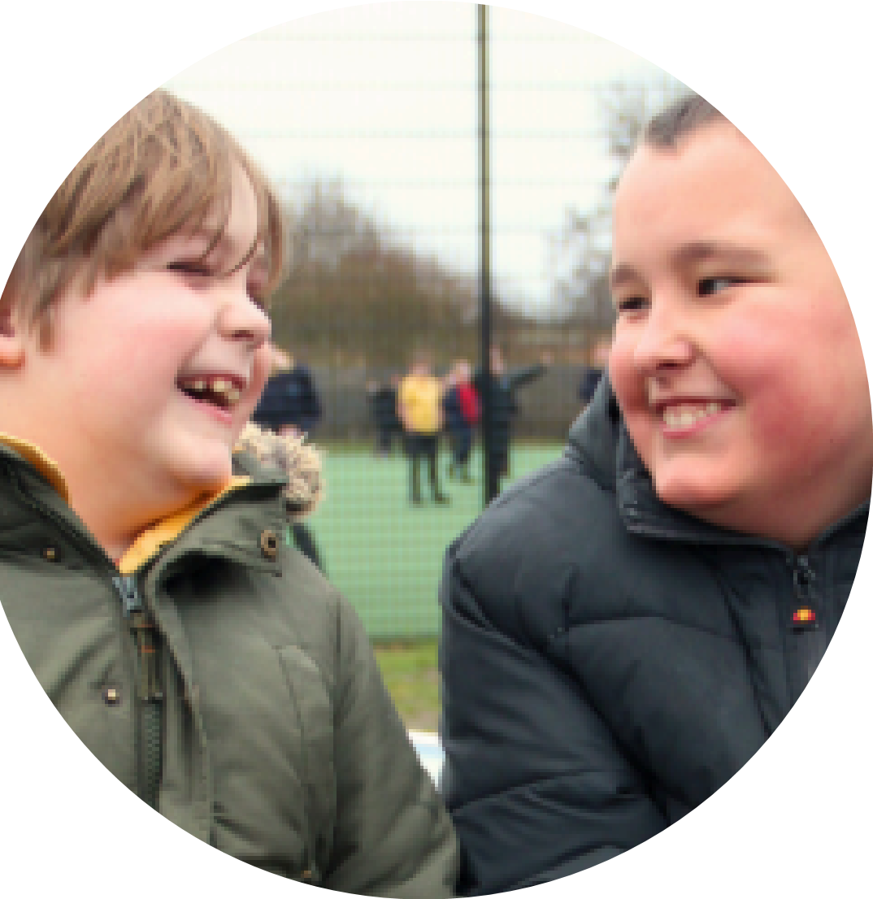
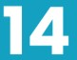
Our SRB is a 16 place provision for pupils from
Reception to Year 6, with a primary need of
social communication differences, including autism.
We have two classrooms, namely:
Thunberg Class (EYFS/KS1)
, named after
Greta Thunberg, an autistic climate justice
activist known for challenging world leaders
to take action to improve our environment
Arday Class (KS2)
, named after Professor
Jason Arday, a sociologist, writer and
fundraiser who was diagnosed with autism at
three years old, pre-verbal until the age of
eleven and is now the youngest black
professor at the University of Cambridge.
Georgia Jones is the Specialist Resource Base
Lead. She has significant experience working
in SEND, teaching and leading in mainstream,
but primarily complex and special
educational needs schools.
All SRB staff have experience, are trained in or
are actively engaged in continuous
professional development related to working
with autistic pupils. All staff have completed
the Autism Education Trust Good Autism
Practise training.
htt
ps://www.drake.norfolk.sch.uk/
pa
g
e/
?
title=Autism+S
pecialist+Resource+Base+%28
S
RB%29&
pid=10
1

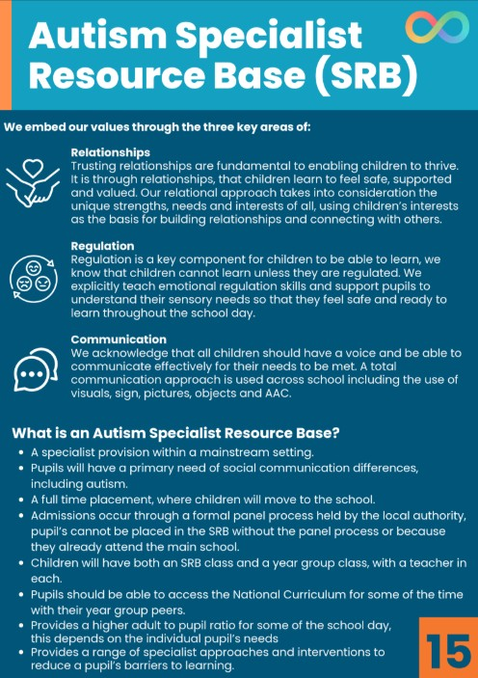

SEND Profile at Drake Primary School
This academic year, 22.8% of our pupils receive extra support in their learning due to Special Educational Needs. This is due to an increase in pupils accessing
specialist support from a Speech and Language Therapist as well as an increase in pupils seeking community referrals for neurodiversity referrals due to different presentation of need at home and school environments. However, successful,
effective early intervention and clearer identification systems have contributed to stability in pupils at SEND Support at Drake Primary School.
16
16
SEND Register | Drake Primary School | Norfolk Primary Overall | National Primary Overall
Total Pupils with SEND | 22.8  % | 20  % | 19.5%
Total Pupils with EHCP | 8% | 6.6% | 5.3  %
Total Pupils at SEND Support | 14.8% | 14.5% | 14.2  %
The data above shows that we have a higher percentage of children with EHCPs compared to Norfolk and National averages, where our figures for children
working at SEND support are more in line with National figures. This shows a
significant shift in statistics from the year 2024-25, where we have strengthened our universal offer so that more children are supported without targeted
provision. We continue to prioritise identification of need so that appropriate and necessary EHCP referrals can be actioned.
Primary Type of 1717
Special Educational Need
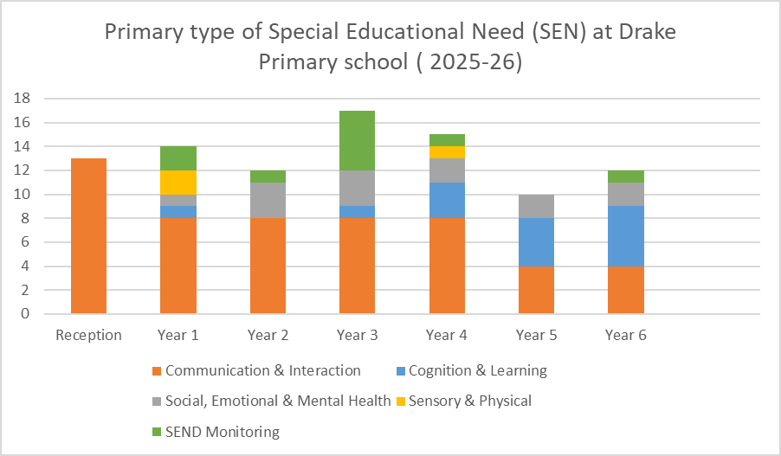
Commentary:
The chart above is based on each pupil’s primary need (main area of support) but it is important to note that some pupils may have secondary needs not recorded here. 2% of pupils are undergoing monitoring and initial cycles of Assess, Plan, Do and Review. For these pupils, further assessments, observations and monitoring are in place to be able to determine SEND and a primary area of need that is the main barrier to their learning.
These figures show that SEN/D is relatively evenly distributed across all year groups. Years 1, 3 and Year 4 currently have the highest levels of SEN.
The year groups receiving the highest proportion of support for SEN are Reception, Year 2 and Year 6. This reflects the needs of individual children and is allowing us to collaborate with external specialists or process referrals.
The biggest area of need is Communication and Interaction which includes children with speech and language difficulties as well as specific interaction diagnosis such as Autism. This matches our highest expenditure of training and links to our work across school with our Autism Specialist Resource Base. This also matches national statistics for SEND.
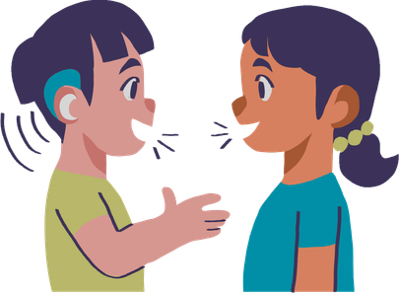
Pupil and Family 1818 Voice
Pupils with SEN and their families are at the heart of SEN practice at Halcyon. We consult with pupils and parents through every step of the Assess, Plan, Do, Review cycles in addition to termly meetings between parents and class teachers. We encourage children with SEN and any parents to talk to us directly if they have a concern so that we can work together to find a solution and support every child.
Pupil Voice
All pupils are supported to participate, understand and give views on our school SEN practice. This happens through:
EHCP Annual Review child voice collection
School councils and ambassadors
Collecting wishes and feelings
School clubs and events
Pupil voice questionnaires
Our children are provided with a total communication approach in order to share their pupil voice in a way that works for them. This includes, but is not limited to verbal communication, visual supports, communication boards and signs.
Parents as Partners
If your child is on the SEN register, we will communicate with you about your child’s needs and progress at least three times a year. If there are any changes or concerns regarding your child’s learning or development, we will contact you for a further collaborative conversation.
We communicate with parents and invite them to share their voice through the following:
Annual Review meetings Parent evenings
One Page Profile meetings
Parents as Partners cafe’s SEND meetings
Pupil Support Plan meetings
Parent questionnaires
Home-school communication books
Online communication systems such as Parent Hub or Tapestry.
Expertise and 19
Professional Development

Halcyon Staff
The school SENDCo, Hannah Bridge, is a qualified Teacher with a National Award for SEN Coordination. She has significant experience and training in supporting children with additional needs in a mainstream setting. Miss Bridge works within the school Pastoral and Senior Leadership Teams.
All staff at Drake Primary School receive formal and informal SEND training throughout the school year.
Accredited training courses are also attended by specific members of staff in order to ensure that best practice is shared across the school. We have a wide selection of resources and training available to support the children. This includes but is not limited to:

Emotional Literacy Support Assistants
Zones of Regulation
Lego Therapy
Forest Schools
Drawing and Talking Therapy
Boxall Profiling
Mental health champion
Precision teaching
The PACE approach
Norfolk Steps
Trauma and attachment
WellComm Speech and Language Assessment
Communication Champion support for Speech and Language difficulties A range of specific medical training as dictated by Individual Healthcare Plans.
Expertise and 20
Professional Development
External Specialists
We work closely with a range of external professionals to seek advice or provide interventions for pupils with SEN and support their families.
Employed by Halcyon
Play Therapists
Speech and Language Therapists (Communicate)
External Referrals
Speech and Language Therapist (NHS)
Educational Psychologists
Virtual School Sensory Support
Occupational Therapists
Neuro-Diversity Assessment Teams
Norfolk Inclusion Team
SEND Local
Offer
Further information on Norfolk’s Local Offer
and parental guides can be found

her
e
.

Each county council has a Local Offer. This is published
information all in one place, describing the provision or
expected provision in an area for children with SEN and their
families.

SEND = Special Educational Needs
Local = In Norfolk
Offer = What is available
https://www.norfolk.gov.uk/SEND
21
21

SEND Funding ²²²²
Specific funding, known as Element 2 and High Needs funding, for pupils with SEN allows us to provide most of the facilities, equipment, resources and expertise needed to support our pupils. For a detailed explanation on how school’s secure SEN funding and a further link to Drake’s funding allocation, please visit Norfolk County Council’s website here.
Drake Primary School SEN Funding
Allocations
For the academic school year 2025-26, Our SEN funding that is updated and outlined through the graduated provision map provided by Norfolk county council has provided;
Specialist and additional support for children with high SEN needs.
SEND-specific training and CPD led by external agencies and professionals including; Attention autism, Colourful semantics and Trauma-informed practice.
Provision mapping software to track and monitor the impact of interventions and SEND provision.
Specialist and bespoke interventions run by full qualified professionals such as; Access to Music and Nurture forest schools sessions.
We continue to review and update our graduated provision mapper to reflect the needs of our pupils and the support in place across the school at universal, targeted and specialist levels.
Transitions for 2323
Pupils with SEND

Admission Arrangements
All admissions to the school are in line with Norfolk County Council’s Admission Policies. There is no differentiation made between pupils with, or without, special educational needs.

Joining Drake primary school
Pupils with SEND may require specific arrangements when transferring between phases of education or schools. We welcome all new pupils joining our school and invite them participate in a site tour. Pupils and parents are invited to share information about themselves and will be given opportunities to meet their new class teacher and other key adults. For pupils with SEN, we will work with families and external professionals to include additional transition plans.

Leaving Drake Primary school
For those children in Year 6 transitioning to a secondary school, we have a full program of transition with our feeder Secondary schools. We work with the secondary schools to provide additional support for children who could be vulnerable or particularly anxious during the period of transition. This may include additional visits to the schools in order to meet key members of staff and an additional opportunity to get to know the school buildings. These opportunities are provided based on the needs of individual children. For children with SEN transitioning to another mainstream primary school or special education setting, we work closely with the new staff team to ensure that relevant information, plans and documentation are shared. The school SENDCo’s will meet to create a plan for transition and additional support put in place. This may include supported visits to the new setting or key members of staff from the new school attending sessions at the child’s current school in order to get to know the child. Pupils with SEN and their families are fully included in this process and will be communicated with throughout, including through the use of social stories.
Drake Primary school is situated on the Fairfields estate in Thetford. In 2016, the school building undertook significant renovation to increase our pupil capacity and ensure that our school site met the needs of every child on our roll.
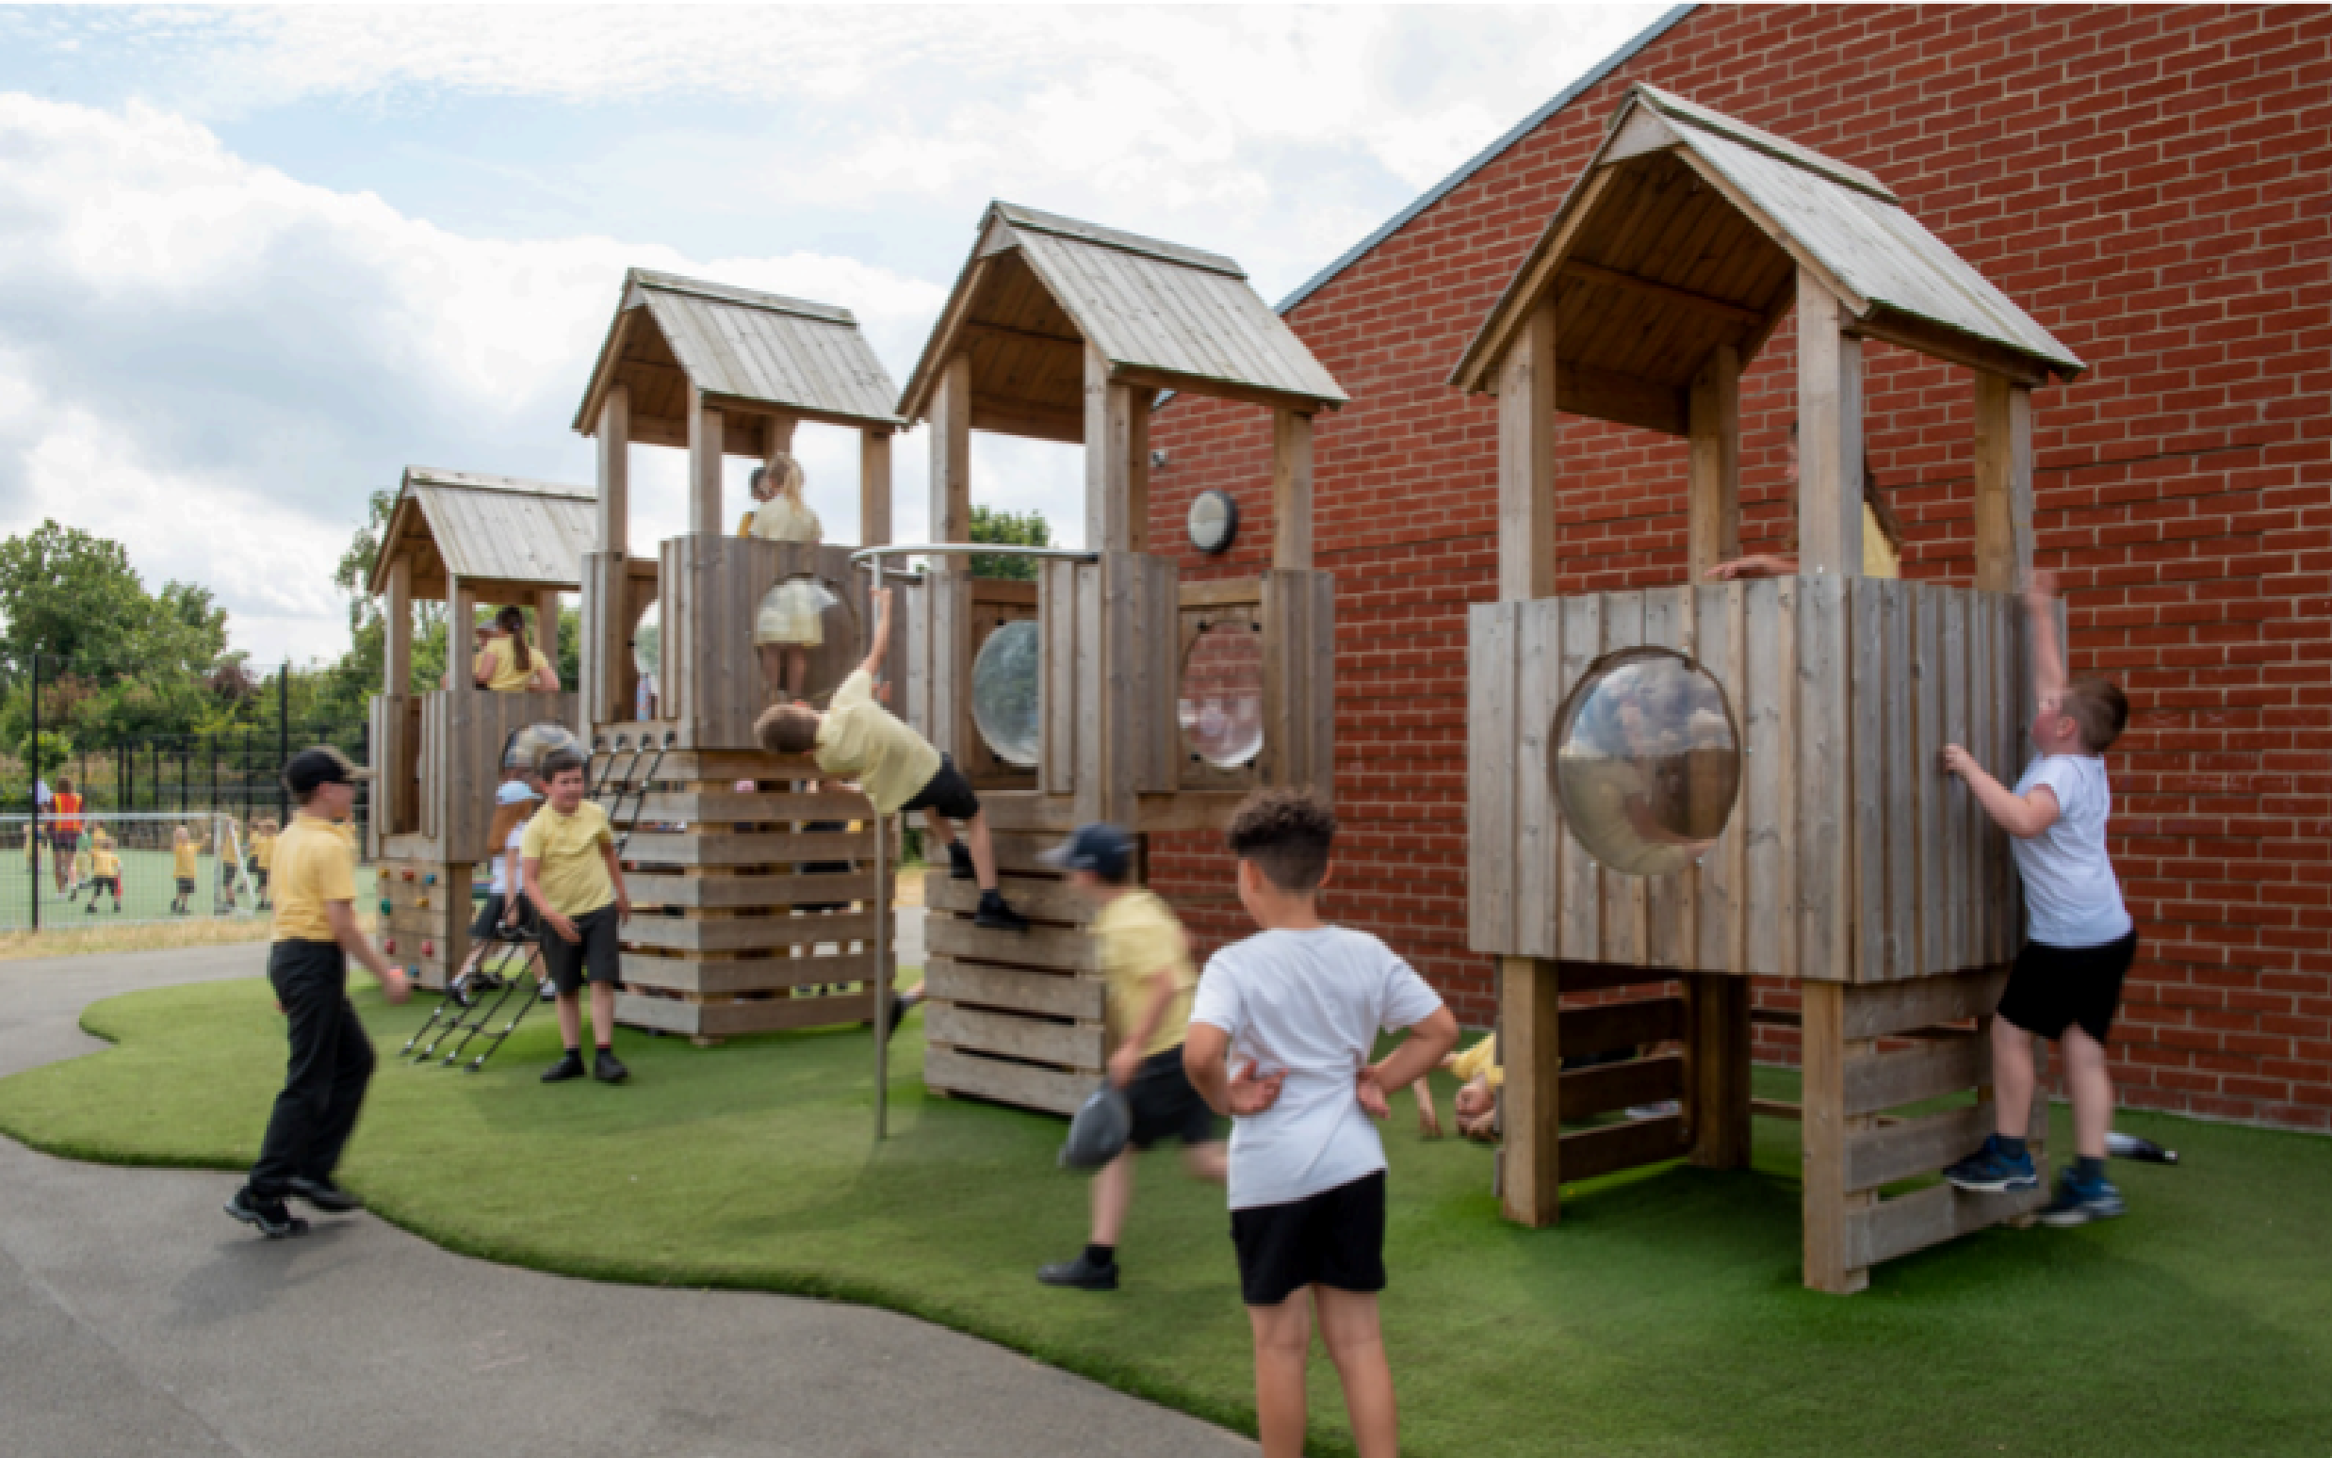
As a result, our building is a single-story, disability friendly, spacious and inviting site. In addition to 14 classrooms, we benefit from specific intervention rooms, a forest school area and an ASD Specialist Resource Base. Accessible toilets are available throughout the building.
24
24
Facilities

As of September 2022, we began further building work to construct a new
Reception block and refit our Autism Specialist Resource Base. This has created increased access to the outdoor area for Reception children and improved
resourcing and provision for children who need specialist support to access
mainstream learning. Additionally, all children will benefit from increased area for play and forest school. For more information about how our school increases access to education for children with disabilities, please see our Accessibility Plan.

Signposting 2525
For free confidential and impartial information, advice and support, contact Norfolk SEND Partnership or Norfolk’s SEND & Inclusion Support Line on:
Norfolk SEND Partnership - 01603 704040
Email - sendpartnership.iass@norfolk.gov.uk


Website - https://www.norfolksendiass.org.uk/
Norfolk SEND & Inclusion Support Line
0333 313 7165
Website - https://www.norfolk.gov.uk/article/69603/SEND-and-inclusionsupport-line Complaints
If you are not happy with the provision made available for your child, please contact your child’s class teacher or discuss your concerns with the school SENDCo. They can be contacted through the school office - office@drake.norfolk.sch.uk
For further information on how to make a formal complaint, please see our Complaints Policy.
26
26
Halcyon
SEND Toolkit
Zones Profile (Risk Management
Plan)
Pastoral Referral Form
One Page Profile
Individual Support Plan
Pastoral Referral 2727 Form
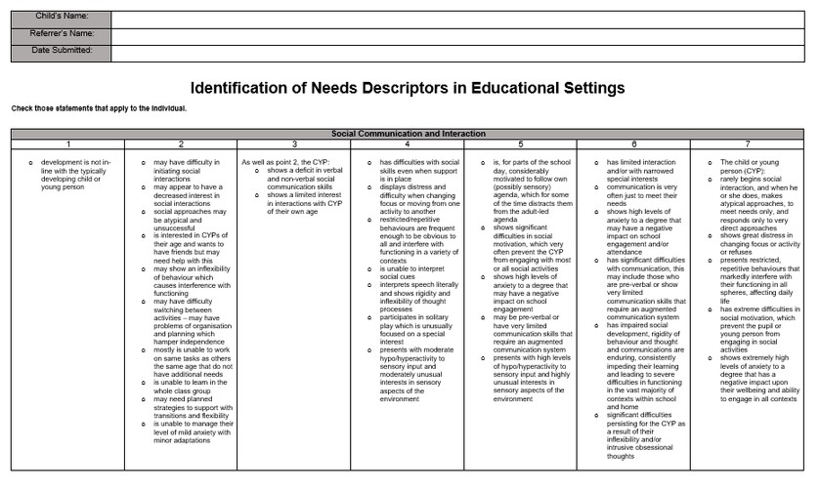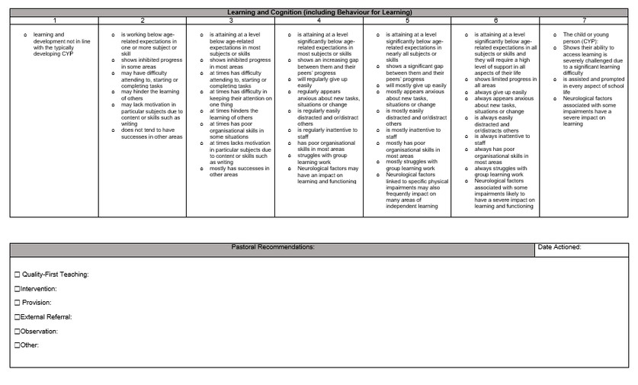
One Page Profile 2828
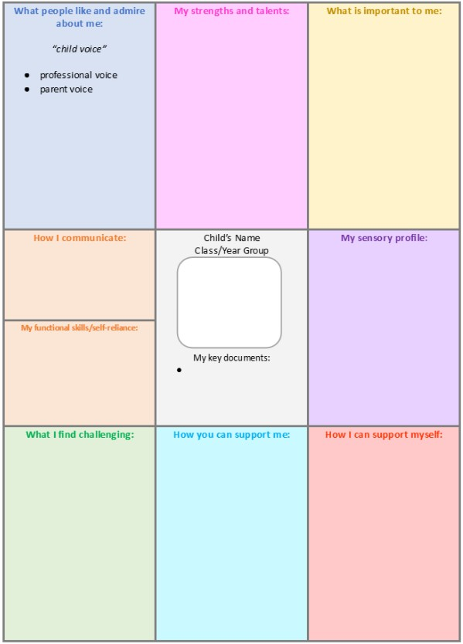
Individual Support 29²⁹ Plan
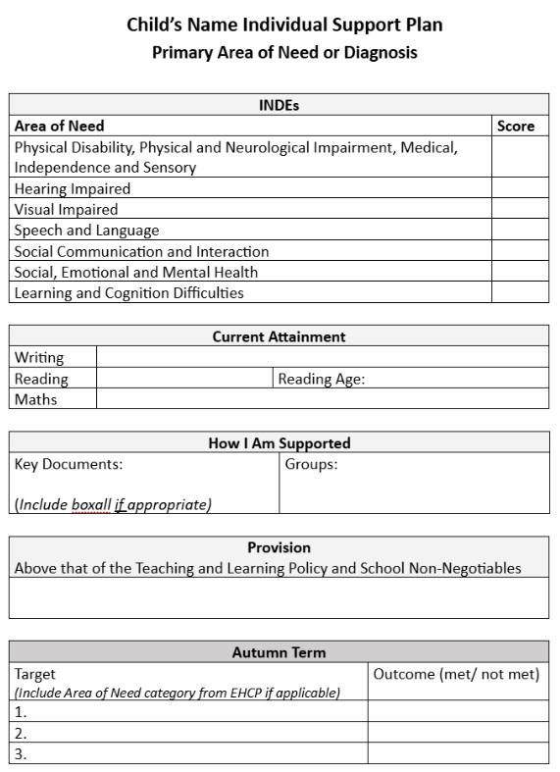
Zones Profile (IRMP) 3030


