FIRST AID POLICY

Approved by: | Executive Head – Louise Clements McLeod  Head of School – Victoria Langley
Created on:- | November 2025

We aim to provide:
- a school where learning is visible and children are safeguarded and nurtured
- a rigorous assessment system to ensure no pupil falls behind
- a diverse learning community where pupils, families and staff collaborate to refine practice and develop positive and rewarding relationships
- a workplace where staff contribute to professional learning communities; locally, nationally and globally.
So our mission is to:
- inspire the poets, geneticists and astronauts of the future
- ensure children are happy and healthy through our values and play
- develop a culture where reading for pleasure is for everyone
- make the arts a central component for children’s lifelong learning
- build a curriculum of joy and curiosity

Contents
1. Aims 2
2. Legislation and guidance 2
3. Roles and responsibilities 3
4. First aid procedures 4
5. First aid equipment 5
6. Record-keeping and reporting 5
7. Training 7
8. Monitoring arrangements 7
9. Links with other policies 7
Appendix 1: list of trained first aiders 9
Appendix 2: picture of accident log book 10

1. Aims
The aims of our first aid policy are to:
- Ensure the health and safety of all staff, pupils and visitors
- Ensure that staff and governors are aware of their responsibilities with regards to health and safety
- Provide a framework for responding to an incident and recording and reporting the outcomes

2. Legislation and guidance
This policy is based on the Statutory Framework for the Early Years Foundation Stage, advice from the Department for Education on first aid in schools and health and safety in schools, guidance from the Health and Safety Executive (HSE) on incident reporting in schools, and the following legislation:
- The Health and Safety (First-Aid) Regulations 1981, which state that employers must provide adequate and appropriate equipment and facilities to enable first aid to be administered to employees, and qualified first aid personnel
- The Management of Health and Safety at Work Regulations 1992, which require employers to make an assessment of the risks to the health and safety of their employees
- The Management of Health and Safety at Work Regulations 1999, which require employers to carry out risk assessments, make arrangements to implement necessary measures, and arrange for appropriate information and training
- The Reporting of Injuries, Diseases and Dangerous Occurrences Regulations (RIDDOR) 2013, which state that some accidents must be reported to the Health and Safety Executive (HSE), and set out the timeframe for this and how long records of such accidents must be kept
- Social Security (Claims and Payments) Regulations 1979, which set out rules on the retention of accident records
- The School Premises (England) Regulations 2012, which require that suitable space is provided to cater for the medical and therapy needs of pupils

3. Roles and responsibilities
3.1 Appointed first aiders
The school’s appointed first aiders are listed in annex 1. Their names will be displayed prominently around the site They are responsible for:
- Taking charge when someone is injured or becomes ill
- Ensuring there is an adequate supply of medical materials in first aid kits, and replenishing the contents of these kits
- Ensuring that an ambulance or other professional medical help is summoned when appropriate
First aiders are trained and qualified to carry out the role (see section 7) and are responsible for:
- Acting as first responders to any incidents; they will assess the situation where there is an injured or ill person, and provide immediate and appropriate treatment
- Sending pupils home to recover, where necessary
- Filling in an accident report on the same day as, or as soon as is reasonably practicable after, an incident (see the template in appendix 2)
- Keeping their contact details up to date

3.2 The local authority and governing board
Norfolk County Council has ultimate responsibility for health and safety matters in the school, but delegates responsibility for the strategic management of such matters to the school’s governing board.
The governing board delegates operational matters and day-to-day tasks to the head of school and staff members.
3.3 The head of school
The head of school is responsible for the implementation of this policy, including:
- Ensuring that an appropriate number of trained first aid personnel are present in the school at all times
- Ensuring that first aiders have an appropriate qualification, keep training up to date and remain competent to perform their role
- Ensuring all staff are aware of first aid procedures
- Ensuring appropriate risk assessments are completed and appropriate measures are put in place
- Undertaking, or ensuring that managers undertake, risk assessments, as appropriate, and that appropriate measures are put in place
- Ensuring that adequate space is available for catering to the medical needs of pupils
- Reporting specified incidents to the HSE when necessary (see section 6)
3.4 Staff
School staff are responsible for:
- Ensuring they follow first aid procedures
- Ensuring they know who the first aiders in school are
- Completing accident log book reports/ accident form (see appendix 2) for all incidents they attend to
- Informing the head of school or their manager of any specific health conditions or first aid needs

4. First aid procedures
4.1 In-school procedures
In the event of an accident resulting in injury:
- The closest member of staff present will assess the seriousness of the injury and seek the assistance of a qualified first aider, who if appropriate, will provide the required first aid treatment
- The first aider, if called, will assess the injury and decide if further assistance is needed from a colleague or the emergency services. They will remain on the scene until help arrives
- The first aider will also decide whether the injured person should be moved or placed in a recovery position
- If the first aider judges that a pupil is too unwell to remain in school, parents will be contacted and asked to collect their child. Upon their arrival, the first aider will recommend next steps to the parents
- If emergency services are called, a member of staff will contact parents immediately
- The relevant member of staff will complete an accident report on the same day or as soon as is reasonably practical after an incident resulting in an injury
There will be at least 1 person who has a current paediatric first aid (PFA) certificate on the premises at all times.
4.2 Off-site procedures
When taking pupils off the school premises, staff will ensure they always have the following:
- A school mobile phone
- A portable first aid kit including, at minimum:
- 6 individually wrapped sterile adhesive dressings
- 1 large sterile unmedicated dressing
- 2 triangular bandages – individually wrapped and preferably sterile
- 2 safety pins
- Individually wrapped moist cleansing wipes
- 2 pairs of disposable gloves
- Information about the specific medical needs of pupils
- Parents’ contact details
When transporting pupils using a minibus or other large vehicle, the school will make sure the vehicle is equipped with a clearly marked first aid box containing, at minimum:
- 10 antiseptic wipes, foil packed
- 1 conforming disposable bandage (not less than 7.5cm wide)
- 2 triangular bandages
- 1 packet of 24 assorted adhesive dressings
- 3 large sterile unmedicated ambulance dressings (not less than 15cm × 20 cm)
- 2 sterile eye pads, with attachments
- 12 assorted safety pins
- 1 pair of rustproof blunt-ended scissors
Risk assessments will be completed by the relevant individual prior to any educational visit that necessitates taking pupils off school premises.
There will always be at least 1 first aider with a current paediatric first aid (PFA) certificate on school trips and visits, as required by the statutory framework for the Early Years Foundation Stage.

5. First aid equipment
A typical first aid kit in our school will include the following:
- 20 individually wrapped sterile adhesive dressings (assorted sizes)
- 2 sterile eye pads
- 2 individually wrapped triangular bandages (preferably sterile)
- 6 safety pins
- 6 medium-sized individually wrapped sterile unmedicated wound dressings
- 2 large sterile individually wrapped unmedicated wound dressings
- 3 pairs of disposable gloves
No medication is kept in first aid kits.
First aid kits are stored in:
- Every classroom
- The meeting room next to the school office
- Both school halls
- The school kitchens

6. Record-keeping and reporting
6.1 First aid and accident record books
- Children at School - An entry in the accident log book will be completed by the relevant member of staff on the same day or as soon as possible after an incident resulting in an injury
- Children at Little Ducklings – An accident form is filled in by the staff member that dealt with the incident. This form is then witnessed by another member of staff. This form is signed the parent on collection of the child.
- As much detail as possible should be supplied when reporting an accident
- Records held in the first aid and accident book will be retained in accordance with regulation 25 of the Social Security (Claims and Payments) Regulations 1979, and then securely disposed of. Our retention policy for accident reporting is –
Adults – Date of the incident plus 6 years
Children at School – Date of birth of the child plus 25 years
Children at Little Ducklings – Date of birth of the child plus 21 years
6.2 Reporting to the HSE
The Head of school will keep a record of any accident which results in a reportable injury, disease, or dangerous occurrence as defined in the RIDDOR 2013 legislation (regulations 4, 5, 6 and 7).
The Head of school will report these to the HSE as soon as is reasonably practicable and in any event within 10 days of the incident – except where indicated below. Fatal and major injuries and dangerous occurrences will be reported without delay (i.e. by telephone) and followed up in writing within 10 days.
Staff can report their own accident on OSHENS, Norfolk County Councils online reporting system for health and safety https://norfolkworkingsafely.oshens.com/Login/Default.aspx
School staff: reportable injuries, diseases or dangerous occurrences
These include:
- Death
- Specified injuries, which are:
- Fractures, other than to fingers, thumbs and toes
- Amputations
- Any injury likely to lead to permanent loss of sight or reduction in sight
- Any crush injury to the head or torso causing damage to the brain or internal organs
- Serious burns (including scalding) which:
  - Covers more than 10% of the whole body’s total surface area; or
  - Causes significant damage to the eyes, respiratory system or other vital organs
- Any scalping requiring hospital treatment
- Any loss of consciousness caused by head injury or asphyxia
- Any other injury arising from working in an enclosed space which leads to hypothermia or heat-induced illness, or requires resuscitation or admittance to hospital for more than 24 hours
- Work-related injuries that lead to an employee being away from work or unable to perform their normal work duties for more than 7 consecutive days (not including the day of the incident). In this case, the Head of school will report these to the HSE as soon as reasonably practicable and in any event within 15 days of the accident
- Occupational diseases where a doctor has made a written diagnosis that the disease is linked to occupational exposure. These include:
  - Carpal tunnel syndrome
  - Severe cramp of the hand or forearm
  - Occupational dermatitis, e.g. from exposure to strong acids or alkalis, including domestic bleach
  - Hand-arm vibration syndrome
  - Occupational asthma, e.g from wood dust
  - Tendonitis or tenosynovitis of the hand or forearm
  - Any occupational cancer
  - Any disease attributed to an occupational exposure to a biological agent
- Near-miss events that do not result in an injury, but could have done. Examples of near-miss events relevant to schools include, but are not limited to:
- The collapse or failure of load-bearing parts of lifts and lifting equipment
- The accidental release of a biological agent likely to cause severe human illness
- The accidental release or escape of any substance that may cause a serious injury or damage to health
- An electrical short circuit or overload causing a fire or explosion
Pupils and other people who are not at work (e.g. visitors): reportable injuries, diseases or dangerous occurrences
These include:
- Death of a person that arose from, or was in connection with, a work activity*
- An injury that arose from, or was in connection with, a work activity* and where the person is taken directly from the scene of the accident to hospital for treatment
*An accident “arises out of” or is “connected with a work activity” if it was caused by:
- A failure in the way a work activity was organised (e.g. inadequate supervision of a field trip)
- The way equipment or substances were used (e.g. lifts, machinery, experiments etc); and/or
- The condition of the premises (e.g. poorly maintained or slippery floors)
Information on how to make a RIDDOR report is available here:
How to make a RIDDOR report, HSE
http://www.hse.gov.uk/riddor/report.htm
6.3 Notifying parents
The relevant staff member will inform parents of any accident or injury sustained by a pupil, and any first aid treatment given, on the same day, or as soon as reasonably practicable. Parents will also be informed if emergency services are called.
An accident slip will be sent home with the child. Parents will be told verbally if there is significant damage to the head. Additional medical advice may need to be sought.
6.4 Reporting to Ofsted and child protection agencies (early years only)
The relevant member of staff will notify Ofsted of any serious accident, illness or injury to, or death of, a child while in the school’s care. This will happen as soon as is reasonably practicable, and no later than 14 days after the incident.
The relevant member of staff will also notify the LADO of any serious accident or injury to, or the death of, a pupil while in the school’s care.

7. Training
All school staff are able to undertake first aid training if they would like to.
All first aiders must have completed a training course, and must hold a valid certificate of competence to show this. The school will keep a register of all trained first aiders, what training they have received and when this is valid until (see appendix 3).
The school will arrange for first aiders to retrain before their first aid certificates expire. In cases where a certificate expires, the school will arrange for staff to retake the full first aid course before being reinstated as a first aider.
At all times, at least 1 staff member will have a current paediatric first aid (PFA) certificate which meets the requirements set out in the Early Years Foundation Stage statutory framework. The PFA certificate will be renewed every 3 years.

8. Monitoring arrangements
This policy will be reviewed by the Head of school every year.
At every review, the policy will be approved by the Head of school.

9. Links with other policies
This first aid policy is linked to the:
- Health and safety policy
- Risk assessment policy
- Policy on supporting pupils with medical conditions

Annexe 1. First Aiders in the setting – updated 27.01.2026
Staff name | Type of Qualification | Date Completed | Expires on | Company | Setting
Sarah Schofield | Paediatric First Aid | 08.04.2024 | 07.04.2027 | Anglian Training | School
Claire Jones | Paediatric First Aid | 08.04.2024 | 07.04.2027 | Anglian Training | School
Nicola Grant | Paediatric First Aid | 08.04.2024 | 07.04.2027 | Anglian Training | School
Jo Sinden | Paediatric First Aid | 08.04.2024 | 07.04.2027 | Anglian Training | School
Errin Bowes | Paediatric First Aid | 08.04.2024 | 07.04.2027 | Anglian Training | School
Tracey Hickey | Paediatric First Aid | 08.04.2024 | 07.04.2027 | Anglian Training | School
Vicky Pitchford | Paediatric First Aid | 08.04.2024 | 07.04.2027 | Anglian Training | School
Rosie McGuire | Paediatric First Aid | 24.07.2024 | 23.07.2027 | Anglian Training | School
Alex Adiguzel | Paediatric First Aid | 24.07.2024 | 23.07.2027 | Anglian Training | School
Jess Render | Paediatric First Aid | 24.07.2024 | 23.07.2027 | Anglian Training | School
Tiffany Keavey | Paediatric First Aid | 24.07.2024 | 23.07.2027 | Anglian Training | School
Kelly Valentine | Paediatric First Aid | 24.07.2024 | 23.07.2027 | Anglian Training | School
Niki Arscott | Paediatric First Aid | 24.07.2024 | 23.07.2027 | Anglian Training | School
Kayleigh Fosker | First Aid in School | 11.02.2025 | 10.02.2028 | Anglian Training | School
Elizabeth James | First Aid in School | 11.02.2025 | 10.02.2028 | Anglian Training | School
Nicola Osborne | First Aid in School | 11.02.2025 | 10.02.2028 | Anglian Training | School
Rachel Wilcox | First Aid in School | 11.02.2025 | 10.02.2028 | Anglian Training | School
Liz Creswell | First Aid in School | 11.02.2025 | 10.02.2028 | Anglian Training | School
Eliza Weclawowicz | First Aid in School | 11.02.2025 | 10.02.2028 | Anglian Training | School
Portia Smith | First Aid in School | 11.02.2025 | 10.02.2028 | Anglian Training | School
Sandy Southwell | First Aid in School | 11.02.2025 | 10.02.2028 | Anglian Training | School
Michelle Wiseman | First Aid in School | 11.02.2025 | 10.02.2028 | Anglian Training | School
Amy Coulter | First Aid in School | 11.02.2025 | 10.02.2028 | Anglian Training | School
Gemma Driver | Paediatric First Aid | 22.12.2025 | 21.12.2028 | Anglian Training | School
Jake Catchpole | Paediatric First Aid | 22.12.2025 | 21.12.2028 | Anglian Training | School
Liz Smith | Paediatric First Aid | 22.12.2025 | 21.12.2028 | Anglian Training | School
Megan Kilburn | Paediatric First Aid | 22.12.2025 | 21.12.2028 | Anglian Training | School
Sue Bolton | Paediatric First Aid | 08.04.2024 | 07.04.2027 | Anglian Training | Ducklings
Kelly Lillistone | Paediatric First Aid | 08.04.2024 | 07.04.2027 | Anglian Training | Ducklings
Karen Armes | Paediatric First Aid | 24.07.2024 | 23.07.2027 | Anglian Training | Ducklings
Sue Barke | Paediatric First Aid | 24.07.2024 | 23.07.2027 | Anglian Training | Ducklings
Marissa Woodrow | Paediatric First Aid | 24.07.2024 | 23.07.2027 | Anglian Training | Ducklings
Glenda Vetere | Paediatric First Aid | 24.07.2024 | 23.07.2027 | Anglian Training | Ducklings
Lorraine Hood | Paediatric First Aid | 24.07.2024 | 23.07.2027 | Anglian Training | Ducklings
Donna Cook | Paediatric First Aid | 24.07.2024 | 23.07.2027 | Anglian Training | Ducklings
Sarah Bartman | Paediatric First Aid | 24.07.2024 | 23.07.2027 | Anglian Training | Ducklings
Stevie Dews | Paediatric First Aid | 22.12.2025 | 21.12.2028 | Anglian Training | Ducklings
Lucy Phillips | Paediatric First Aid | 22.12.2025 | 21.12.2028 | Anglian Training | Ducklings
Theresa Hammond | Paediatric First Aid | 22.12.2025 | 21.12.2028 | Anglian Training | Ducklings
Sam Croome | Paediatric First Aid | 22.12.2025 | 21.12.2028 | Anglian Training | Ducklings
Susan Sayer | Paediatric First Aid | 22.12.2025 | 21.12.2028 | Anglian Training | Ducklings
Dave Shear | Paediatric First Aid | 22.12.2025 | 21.12.2028 | Anglian Training | Ducklings
Rachel Pynen | Paediatric First Aid | 22.12.2025 | 21.12.2028 | Anglian Training | Ducklings
Suzanne Shear | Paediatric First Aid | 17.01.2026 | 16.01.2029 | Tigerlily | Ducklings

Other certificates -
Sara Farish | Forest School First Aid | 14.07.2023 | 14.07.2026 |  | School

Appendix 2: accident log book for School and forms for Little Ducklings

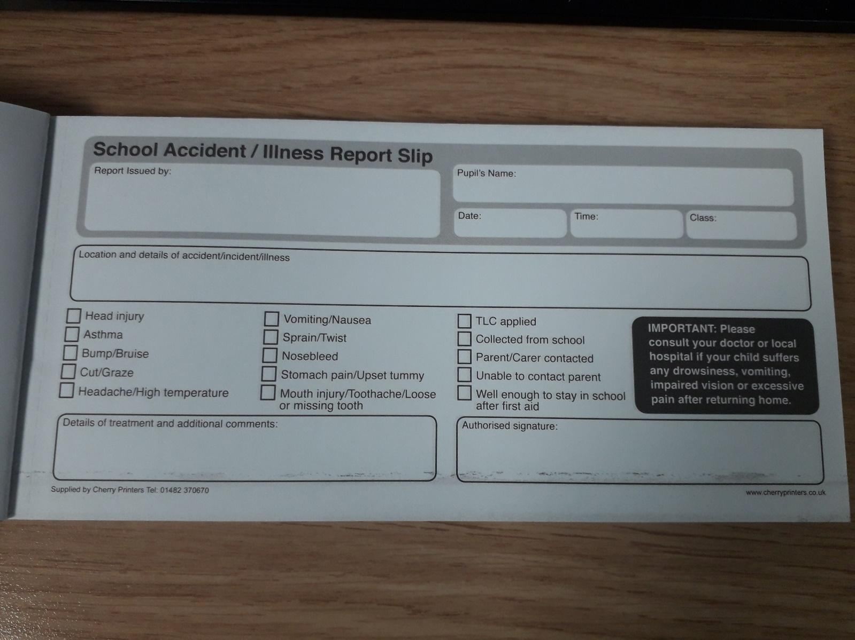

Accident Report Little Ducklings Child Care

Name of Child: Date: Time:
Nature of Injury (Description, size, location on body)

How & where accident took place:

Treatments given:
Action taken:
Signature of two members of staff witnessing event: 1.
2.
Signature of Parent/Carer:

Accident Report - Bumped Head: Little Ducklings Child Care

Name
Date Time
Place
Description:

Injury:

Action:

Your child has been monitored for any changes to normal behaviour:
Headache
Dizziness
Feeling sick or vomiting
Clumsiness/Unbalanced
Unusual behaviour
Confused
Struggling to stay awake/sleeping for longer than normal
Signs for younger children/babies
Crying a lot
Changes in feeding/sleeping habits
Loss of Interest in people/objects

*Phone 111 if unsure

