Topping up your account if your balance is low
If your school requires you to top up funds before signing up, you won't be able to sign up and you'll get an error message.
Here's the message on the Parent Portal.
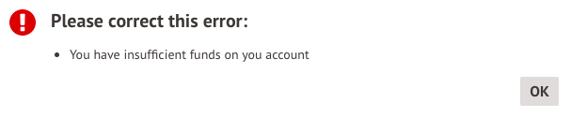

On the App, it will look like this.
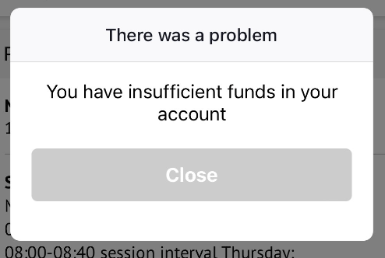

You will need to return to the club page and click Top up account.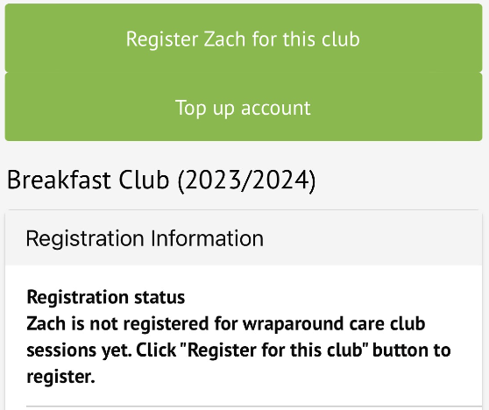

On the Parent App, you can add the amount to your basket.


