To sign up for a club, click the menu icon at the bottom left of your screen. Select Clubs.
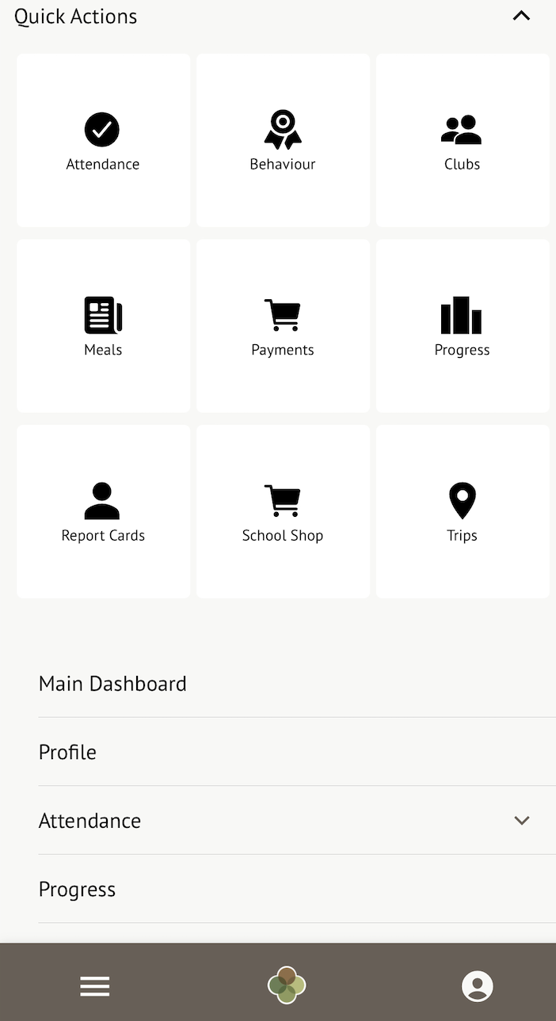

You can then see a list of any clubs your child is attending, and any clubs open to your child.
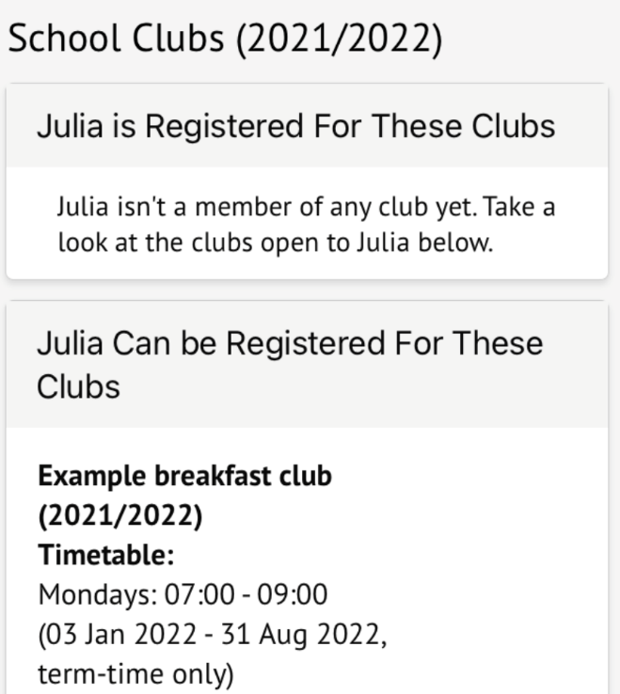

Click a club to access the Club Overview. Click Register For This Club to sign up.
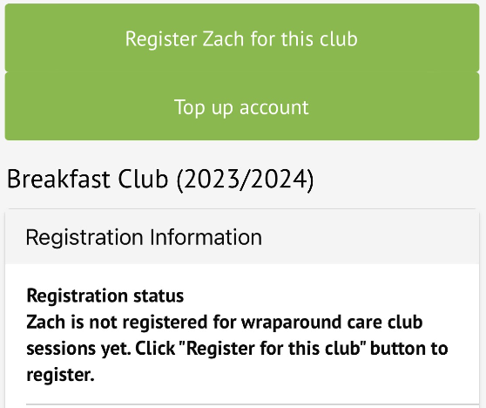

Choose the membership period to sign up for - this may be a day, a term or the whole academic year, depending on what your school has set up.
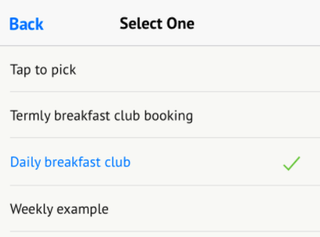
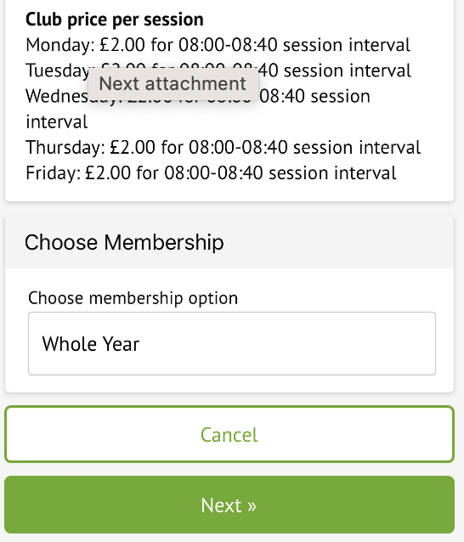

Choose which membership periods to sign up to.
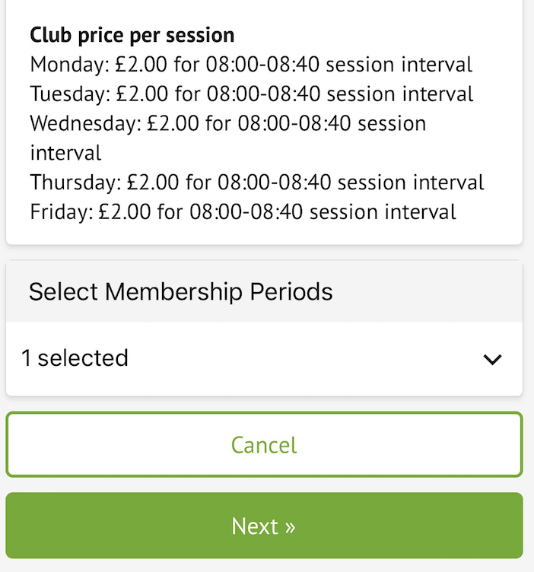

Then select which times to sign up to for the club.
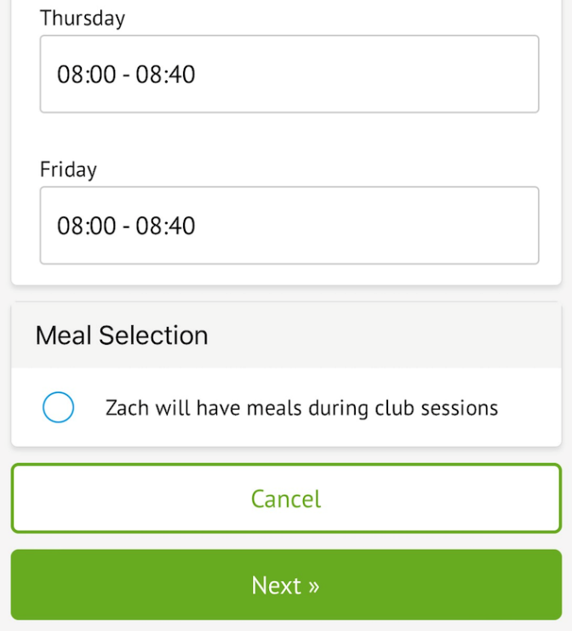

Finally, confirm registration. They will then be signed up.


